Section 4:
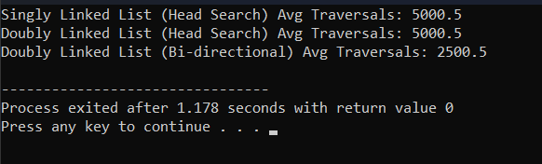
n | Structure / Strategy | Empirical Traversals | Theoretical Worst | Theoretical Avg | Ratio (Empirical / Avg)
10,000 | Singly Linked List (Head Search) | 5000.5 | 10,000 | 5,000 | 1.0001
10,000 | Doubly Linked List (Head Search) | 5000.5 | 10,000 | 5,000 | 1.0001
10,000 | Doubly Linked List (Bi-directional) | 2500.5 | 10,000 | 2,500 | 1.0002

Cấu hình máy: i5 13500hx, 16gb
Giải thích:
Bidirectional traversal in a Doubly Linked List reduces average search comparisons from $n/2$ down to $n/4$ because the search can initiate from either the head or the tail depending on whether the target element is closer to the start or the end of the list. For a uniform random distribution, half of the elements reside within the first half of the list (closer to the head) and are accessed via forward traversal, while the other half reside in the second half (closer to the tail) and are accessed via backward traversal using prev pointers. This effectively halves the average search distance. In contrast, a Singly Linked List is strictly constrained to forward traversal from the head due to the lack of backward pointers, forcing a full linear scan proportional to $n/2$ on average regardless of the element's relative proximity to the tail.

